**Experiment -2.1**

**Student Name: Km Ayushi UID:22BDO10055**

**Branch: CSE(DevOps) Section/Group-22BCD-1(B)**

**Semester: 4th Date of Performance:22/02/24**

**Subject Name- Git and GitHub Subject Code:22CSH-293**

## 1. Aim/Overview of the practical: To Merge Pull Request and Update the local repository on GitHub.

## 2. Software used: Git bash and GitHub

**3. Steps for experiment/practical:**

1. First open GitHub, and create a repository ‘exper5’.

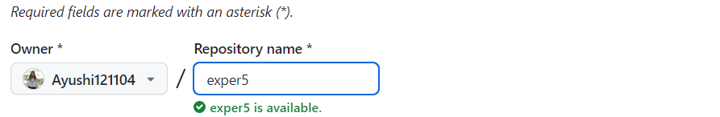

1. On git bash initiate the git command and use the git remote add origin.

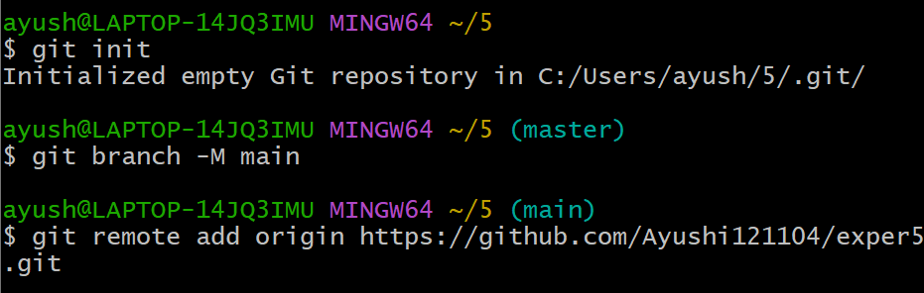

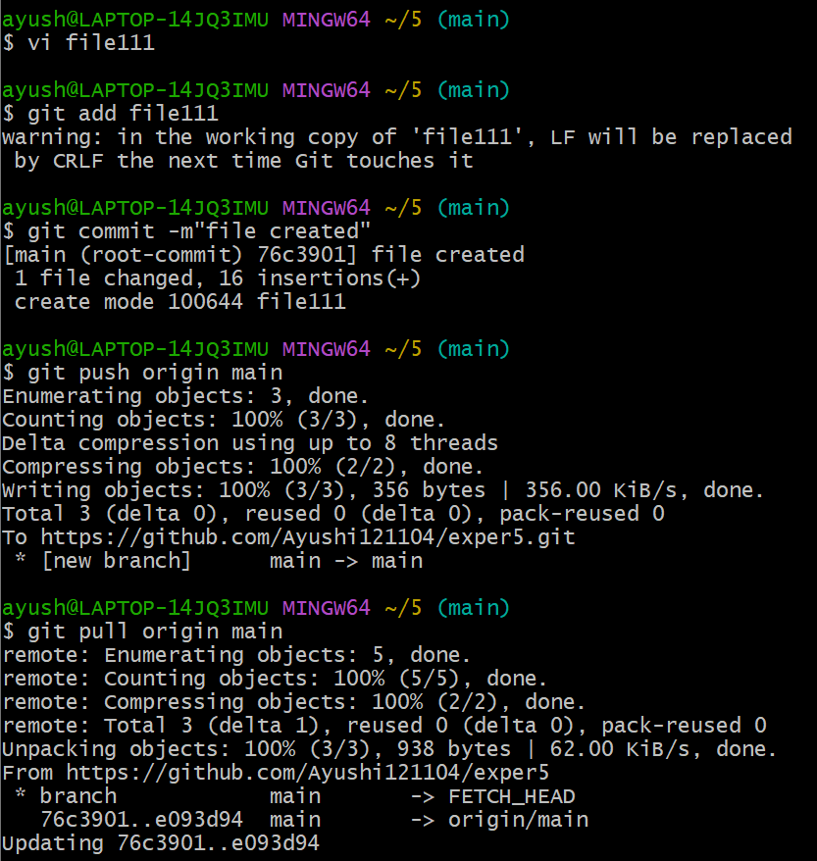

1. Now make a new file name file111 add some code into that file add the file and then commit it in the staging area.
2. Now push the file to the remote repository make some changes on the remote repository and then pull the file in the local repository.

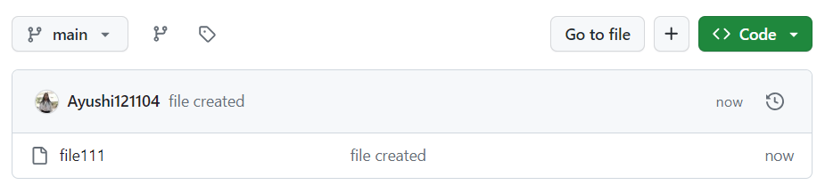

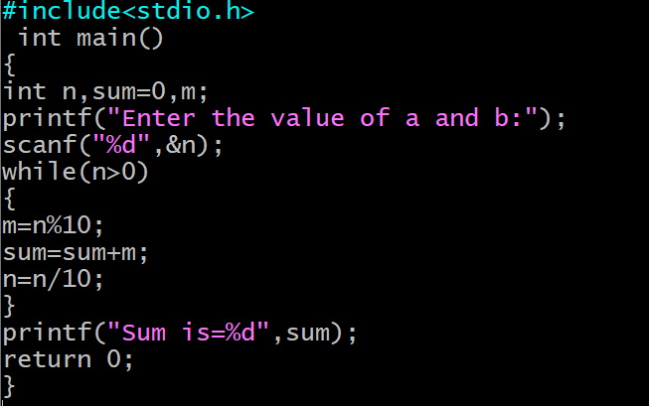 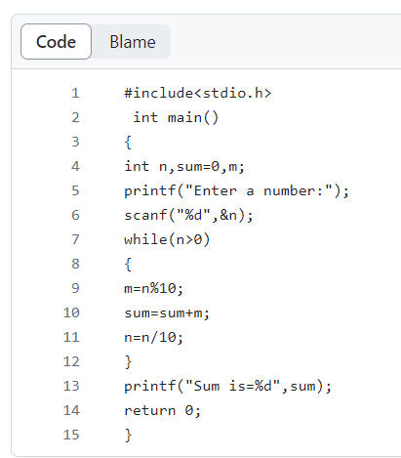

**< Local > <remote>**

1. Now check whether the changes that you have done on the remote repository have been pulled locally or not.
2. Now create a new branch named repo1 open the same file in the new branch and edit it

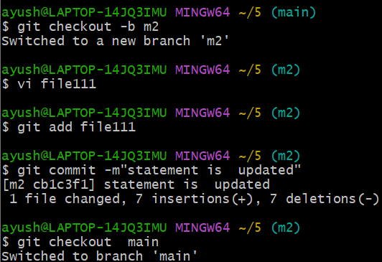

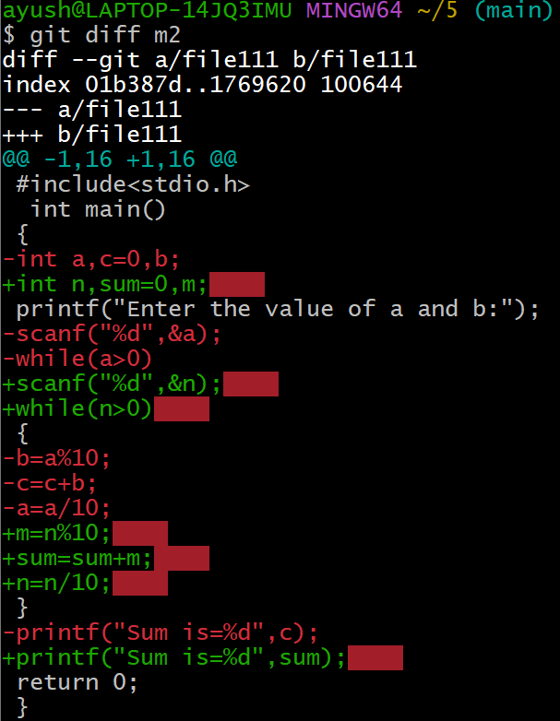

1. Now add the file commit it in the staging area and check the differences between the previous changes that we have made.
2. Now merge the main with the branch and push the main and m2 branches on the remote repository.
3. Changes can be seen easily.
4. Now create the pull request merge the pull request and then confirm the merch pull request.

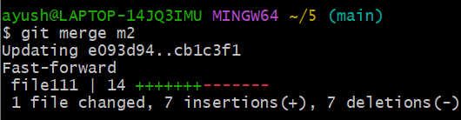

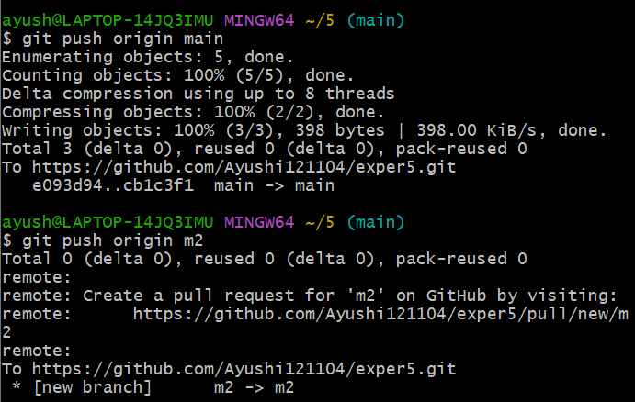

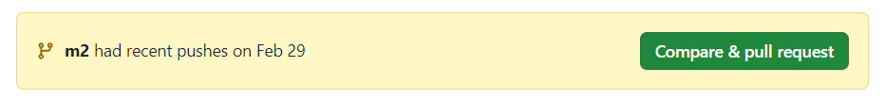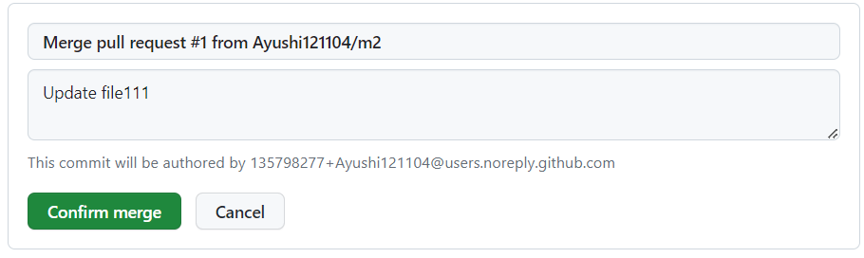

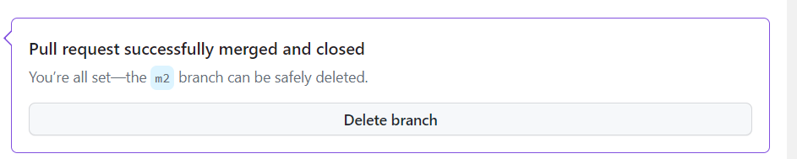

**9. Result/Output/Writing Summary:**

In this experiment, we will edit a file, commit changes on GitHub, observe the differences in the local machine, and push and pull from the local to the remote repository.

**Learning outcomes (What I have learnt):**

1. Learn about repositories without cloning.

2. Learn about Editing a file locally and repository.

3. Learn How to push from local to remote and vice versa.

4. Learn how to check the differences in the local machine.

5. Learn how to match the branch with the main branch.

**Evaluation Grid (To be created as per the SOP and Assessment guidelines by the faculty):**

|  |  |  |  |
| --- | --- | --- | --- |
| Sr. No. | Parameters | Marks Obtained | Maximum Marks |
| 1. |  |  |  |
| 2. |  |  |  |
| 3. |  |  |  |
|  |  |  |  |